1. Launch Vivado

2. Click on Create New Project to start the Wizard

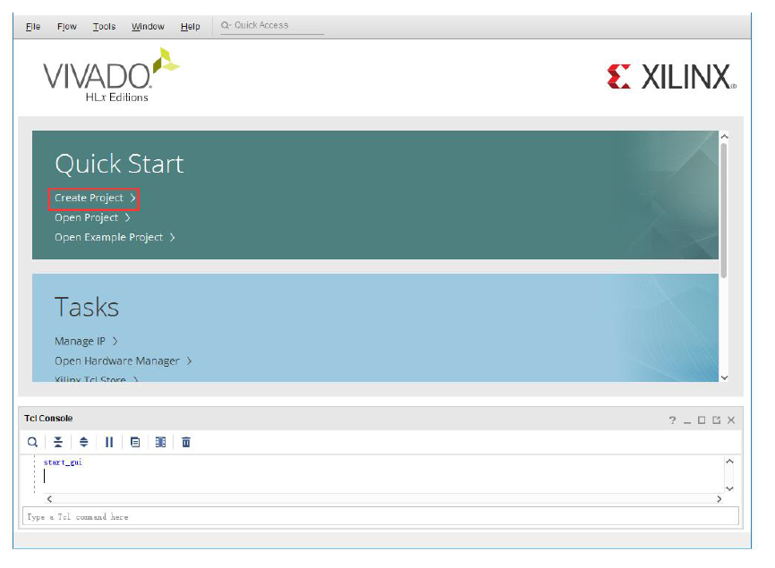

3. Click Next on the Create a New Vivado Project pop-up

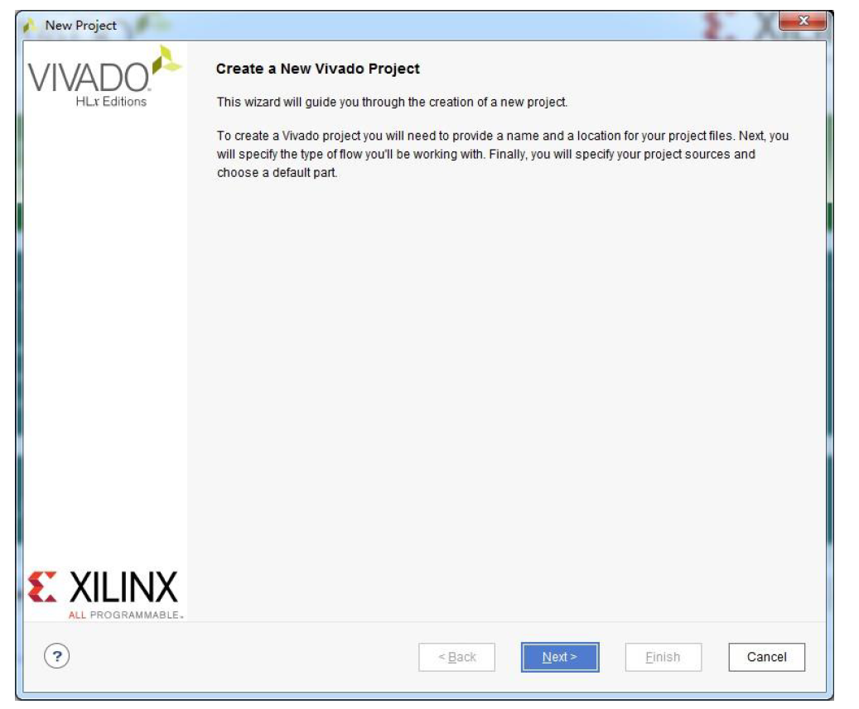

4. Enter the project name and directory in the Project Name pop-up. Note, Vivado will create a folder with the name you provide in the Project name box.

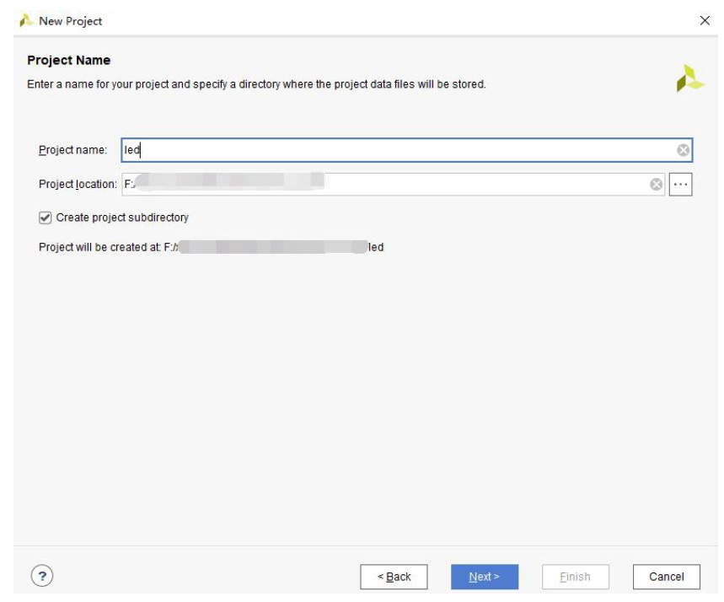

5. Select RTL in the Project Type pop-up.

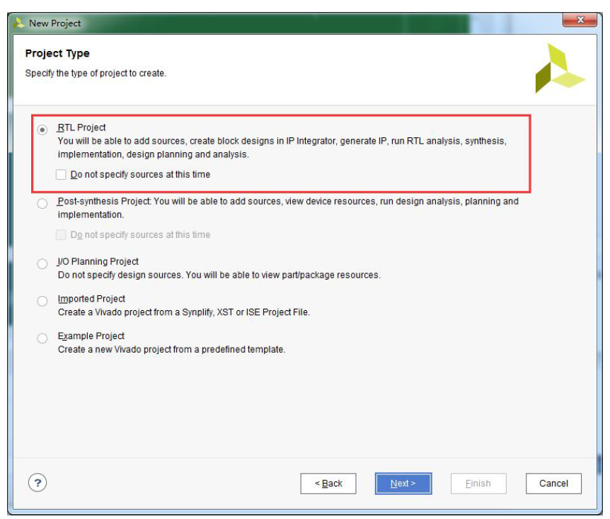

6. Select VHDL in the Add Sources pop-up.

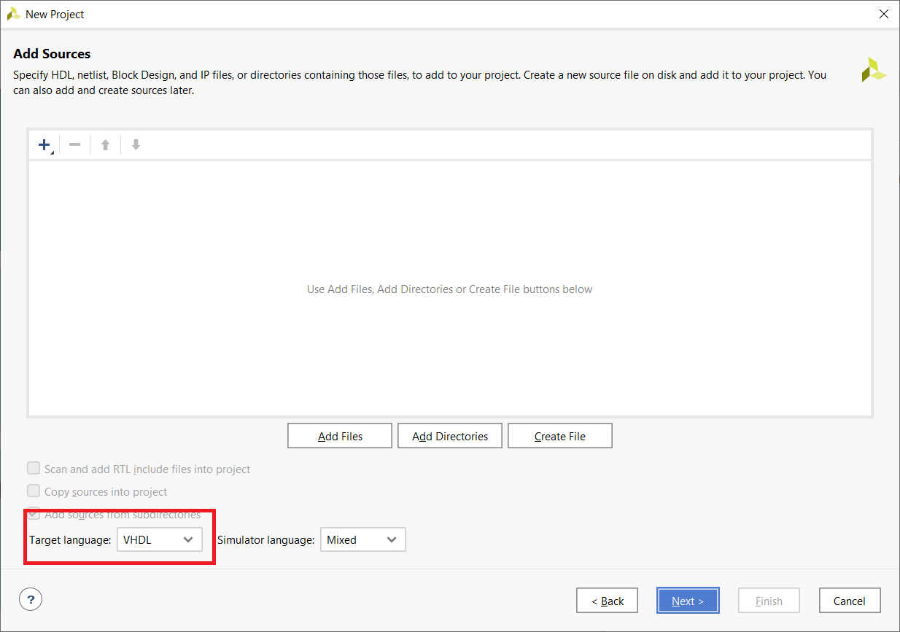

7. Don’t add any constraints in the Add Constraints pop-up.

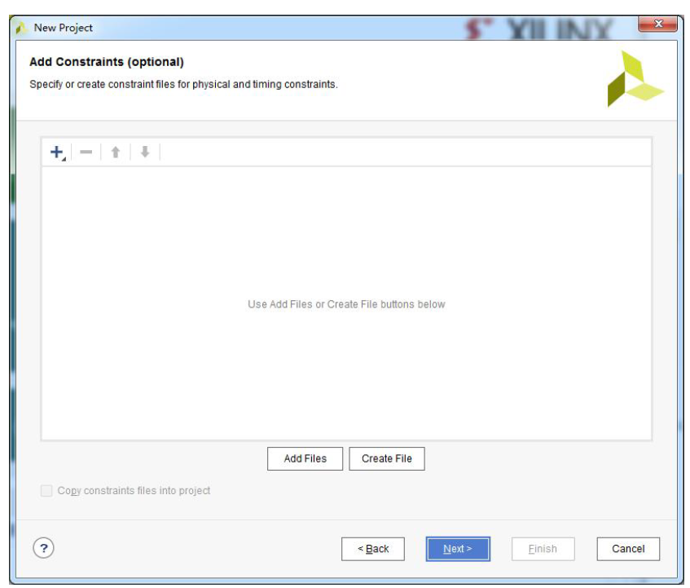

8. In the Default Part pop-up, select

Family: Zynq-7000

Package clg400

Speed grade: -1

Part: xc7z010clg400-1

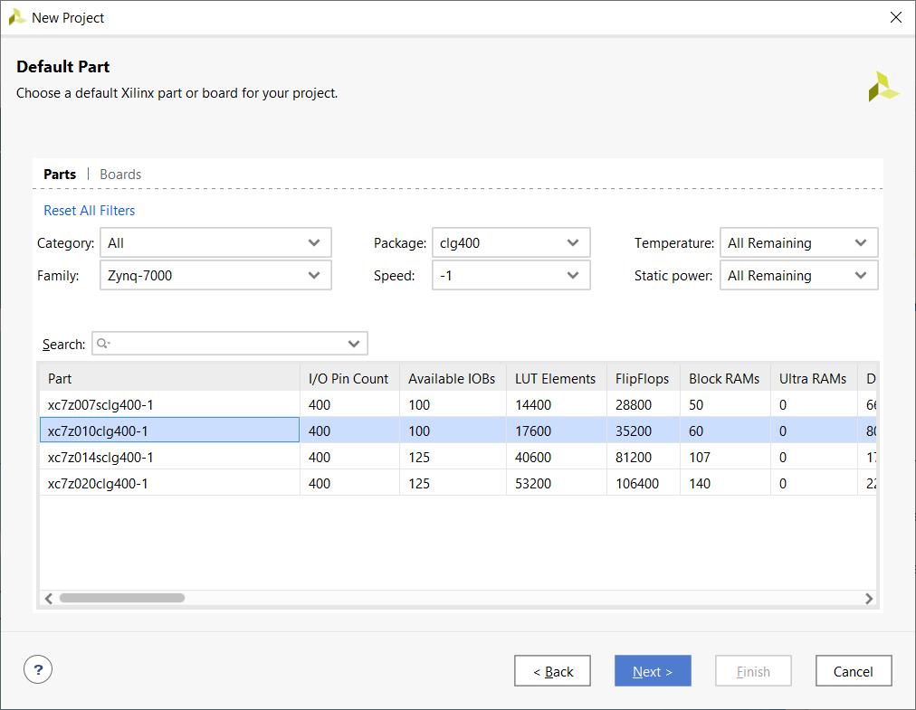

9. Click Finish in the New Project Summary pop-up.